**DAILY ONLINE ACTIVITIES SUMMARY**

|  |  |  |  |  |  |  |  |  |
| --- | --- | --- | --- | --- | --- | --- | --- | --- |
| **Date:** | **19-05-2020** | | | | | **Name:** | **Shashikant Chavan** | |
| **Sem & Sec** | **8th sem B sec** | | | | | **USN:** | **4AL16CS090** | |
| **Online Test Summary** | | | | | | | | |
| **Subject** | | **BDA** | | | | | | |
| **Max. Marks** | | **30** | | **Score** | | | **18** | |
| **Certification Course Summary** | | | | | | | | |
| **Course** | **Python Programming** | | | | | | | |
| **Certificate Provider** | | | **Great learning website** | | **Duration** | | | **10-12.30** |
| **Coding Challenges** | | | | | | | | |
| **Problem Statement: java coding problem** | | | | | | | | |
| **Status: completed** | | | | | | | | |
| **Uploaded the report in Github** | | | | | **yes** | | | |
| **If yes Repository name** | | | | | **Academic** | | | |
| **Uploaded the report in slack** | | | | | **yes** | | | |

Online Test Details: (Attach the snapshot and briefly write the report for the same)

Certification Course Details: (Attach the snapshot and briefly write the report for the same)

Saw videos related to Python Programming

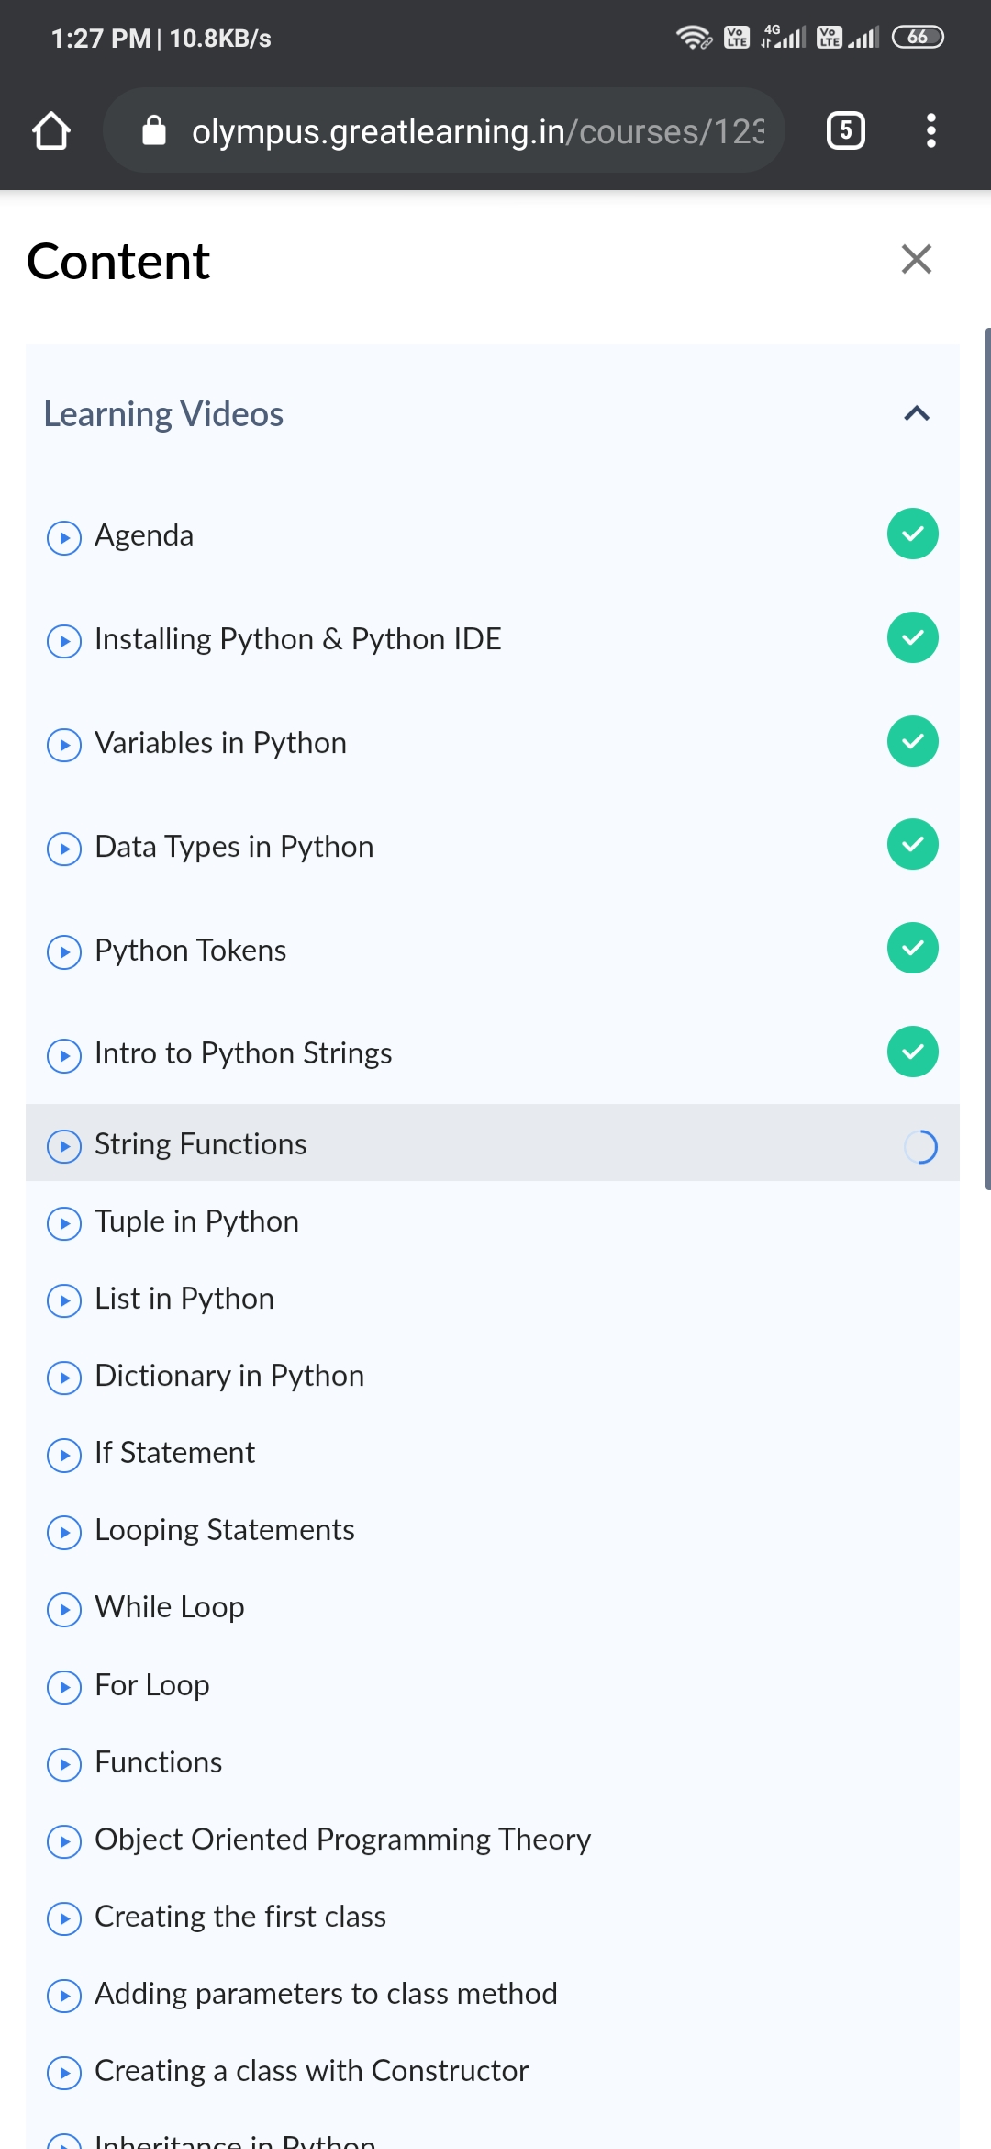

Coding Challenges Details: (Attach the snapshot and briefly write the report for the same)

Coding was given n it was uploaded for github and slack

PROGRAM1

package shortestpalindromeexample.java;

import java.util.Scanner;

public class ShortestPalindromeDemo {

public static String shortestPalindrome(String str) {

int x=0;

int y=str.length()-1;

while(y>=0){

if(str.charAt(x)==str.charAt(y)){

x++;

}

y--;

}

if(x==str.length())

return str;

String suffix = str.substring(x);

String prefix = new StringBuilder(suffix).reverse().toString();

String mid = shortestPalindrome(str.substring(0, x));

return prefix+mid+suffix;

}

public static void main(String[] args) {

Scanner in = new Scanner(System.in);

System.out.println("Enter a String to find out shortest palindrome");

String str=in.nextLine();

System.out.println("Shortest palindrome of "+str+" is "+shortestPalindrome(str));

}

[2:59 PM, 5/19/2020] E Vaibhavi: PROGRAM 2

mport java.util.Stack;

// Data Structure to store a linked list node

class Node {

int data;

Node next;

Node(int i)

{

this.data = i;

this.next = null;

}

};

class Main

{

// Function to determine if a given linked list is palindrome or not

public static boolean isPalindrome(Node head)

{

// construct an empty stack

Stack s = new Stack<>();

// push all elements of the linked list into the stack

Node node = head;

while (node != null) {

s.push(node.data);

node = node.next;

}

// traverse the linked list again

node = head;

while (node != null)

{

// pop the top element from the stack

int top = s.pop();

// compare the popped element with current node's data

// return false if mismatch happens

if (top != node.data) {

return false;

}

// advance to the next node

node = node.next;

}

// we reach here only when the linked list is palindrome

return true;

}

public static void main(String[] args)

{

Node head = new Node(1);

head.next = new Node(2);

head.next.next = new Node(3);

head.next.next.next = new Node(2);

head.next.next.next.next = new Node(1);

if (isPalindrome(head)) {

System.out.print("Linked List is a palindrome.");

} else {

System.out.print("Linked List is not a palindrome.");

}}